Monday |  | Tuesday |  | Wednesday |  | Thursday | Friday
Breakfast includes 100% Fruit Juice on Monday, Wednesday, Friday and a Fruit choice on Tuesday and Thursday. Ice cold Low Fat Milk is provided daily with Breakfast and Lunch. | 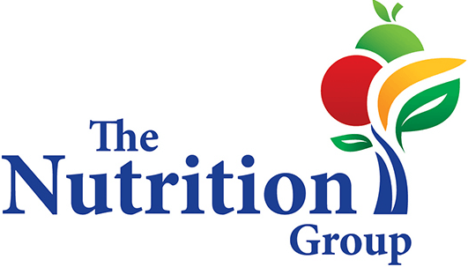 |  | 29 Breakfast  Lunch  Chicken Corn Dog Nuggets, Sweet Potato Fries, Bread  Snack |  | 30 Breakfast  Lunch  Italian Dunkers, Marinara Sauce, Seasoned Green Beans  Snack |  | 31 Breakfast  Lunch  Walking Taco, Whole Grain Bread Slice, Corn  Snack
3  CENTER CLOSED  in observance of LABOR DAY | 4 Breakfast  Lunch  Tuna Melt, Steamed Carrots  Snack |  | 5 Breakfast  Lunch  Chicken Nuggets, Bread Slice, Mashed Potatoes with Gravy  Snack |  | 6 Breakfast  Lunch  Macaroni and Cheese, Dinner Roll, Steamed Broccoli  Snack |  | 7 Breakfast  Lunch  Tony’s Pizza, Sweet Peas  Snack
10 Breakfast  Lunch  Ham and Cheese on a Pretzel Bun, Corn  Snack | 11 Breakfast  Lunch  Meatball Hoagie, Seasoned Green Beans  Snack |  | 12 Breakfast  Lunch  French Toast Sticks, Sausage, Tater Tots  Snack |  | 13 Breakfast  Lunch  Pizzaburger on a Hamburger Bun, Honey Glazed Carrots  Snack |  | 14 Breakfast  Lunch  Popcorn Chicken Bowl, Bread, Mashed Potatoes  Snack
17 Breakfast  Lunch  Turkey Melt on a Whole Grain Pretzel Bun, Smiley Fries  Snack | 18 Breakfast  Lunch  Grilled Cheese Sandwich, Tomato Soup, Sweet Peas  Snack |  | 19 Breakfast  Lunch  BBQ Rib Sandwich, Sweet Potato Fries  Snack |  | 20 Breakfast  Lunch  Breaded Chicken Patty on a Bun, Steamed Broccoli  Snack |  | 21 Breakfast  Lunch  Beef & Cheese Soft Taco, Corn  Snack
24 Breakfast  Lunch  Crispy Fish Sandwich, Tater Tots  Snack | 25 Breakfast  Lunch  Turkey Reuben Sandwich, Honey Glazed Carrots  Snack |  | 26 Breakfast  Lunch  Crispy Chicken Tenders, Bread, Steamed Broccoli  Snack |  | 27 Breakfast  Lunch  Pasta & Homemade Meat Sauce, Bread, Seasoned Green Beans  Snack |  | 28 Breakfast  Lunch  Pulled Pork BBQ, Baked Beans  Snack
August and September 2018 Pre-K Counts Menu
CONNEAUT-2 (VALLEY)

